innerHTML & innerText

1.innerHTML

<html>

    <head>

        <title>innerHTML</title>

    </head>

    <body>

        <script>

            let html=document.getElementById("para").innerHTML;

            document.getElementById("demo").innerHTML=html;

        </script>

        <h1>innerHTML</h1>

        <p id="para">The paragraph is aligned with innerhtml.</p>

        <p id="demo"></p>

    </body>

</html>

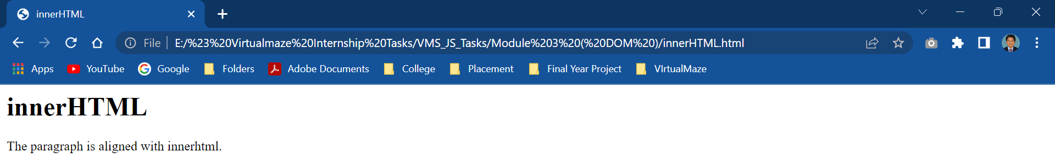

<html>

    <head>

        <title>innerHTML</title>

    </head>

    <body>

        <script>

            function myFunction()

            {

                document.getElementById("demo").innerHTML="I Have Changed";

            }

        </script>

        <h1>innerHTMl</h1>

        <p id="demo" onclick="myFunction()">Click to change this page.</p>

    </body>

</html>

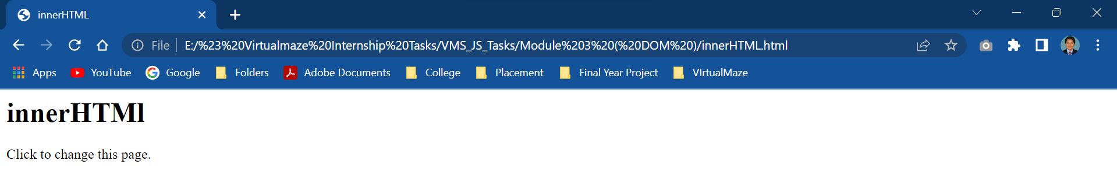



<html>

    <head>

        <title>innerHTML</title>

    </head>

    <body>

        <script>

            function myFunction()

            {

                document.getElementById("demo").innerHTML="";

            }

        </script>

        <h1>innerHTML</h1>

        <p id="demo" onclick="myFunction()">Click the line to delete this Line.</p><br><br>

        <p>Hello</p>

    </body>

</html>

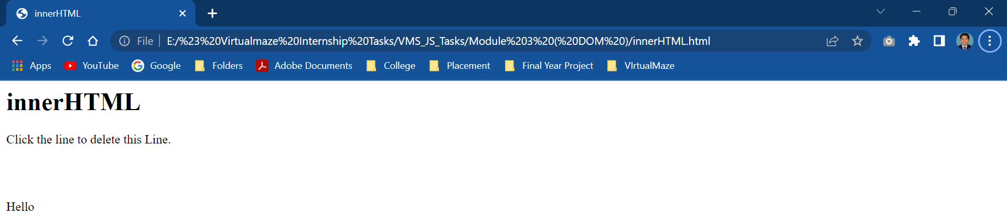

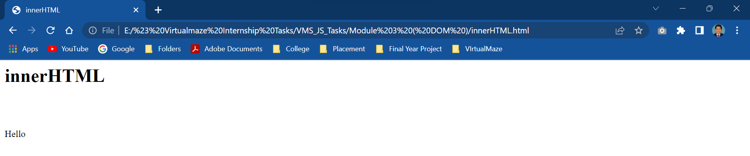

2.innerText :

<!DOCTYPE html>

<html>

<body>

<h1>The Element Object</h1>

<h2>The innerText Property</h2>

<button id="myBtn">Try it</button>

<p>The text content of the button element is:</p>

<p id="demo"></p>

<script>

let text = document.getElementById("myBtn").innerText;

document.getElementById("demo").innerHTML = text;

</script>

</body>

</html>

